Pomegranate-Derived Polyphenols and Alveolar Bone Remodeling in Orthodontic Retention: A Systematic Review and Meta-Analysis

[First Author]¹, [Second Author]¹, [Corresponding Author]*²
¹ [Department, Institution, City, Country]
² [Department, Institution, City, Country]
* Corresponding author: [email@institution.ac.id]
Received: [date] | Accepted: [date] | Published: [date]

ABSTRACT
Background: | Orthodontic relapse occurs in 70–90% of treated patients and is fundamentally a biological phenomenon driven by dysregulated alveolar bone remodeling. Conventional retention devices provide mechanical not biological stabilization, leaving an unmet clinical need for pharmacological adjuncts.
Objective: | To systematically map research trends, synthesize evidence on the effects of pomegranate-derived polyphenols on alveolar bone remodeling during orthodontic retention, and elucidate the underlying biological mechanisms.
Methods: | Following PRISMA 2020 guidelines, a systematic search was conducted in Scopus (2016–2024). A total of 1,327 initial records were progressively filtered to 60 open-access articles. Bibliometric analysis used VOSviewer v1.6.19. Meta-analysis was performed with RevMan 5.4.1 and R v4.3 where data permitted.
Results: | Publication CAGR ≈ 10.9% (2016–2024); Indonesia (28.9%), China (20.0%), and Japan (13.3%) are leading contributors. Ellagic acid significantly upregulated OPG and downregulated RANKL in bone defect models (p = 0.000), reduced TNF-α and IL-6, increased IL-10, and reduced alveolar bone loss in periodontitis models. Four mechanistic pathways identified: (1) RANKL/OPG axis modulation; (2) NF-κB/cytokine inhibition; (3) ROS scavenging via Nrf2/HO-1; (4) pro-osteogenic BMP-2/Wnt/β-catenin stimulation.
Conclusion: | Pomegranate-derived polyphenols particularly ellagic acid and punicalagin target the precise molecular dysregulations characterizing post-orthodontic bone remodeling failure. No study has yet examined these compounds in an orthodontic retention model, representing the most critical gap for future research.
Keywords: | pomegranate; Punica granatum; punicalagin; ellagic acid; orthodontic tooth movement; alveolar bone remodeling; osteoclast; RANKL; OPG; systematic review; bibliometric analysis

1. INTRODUCTION
Orthodontic treatment effectively corrects dentofacial irregularities, yet the long-term stability of its outcomes remains an unresolved clinical challenge. Relapse the tendency of teeth to return toward their pre-treatment positions after active therapy occurs in 70–90% of treated patients, making it one of the most pervasive complications in the field.[1] The problem is particularly pronounced during the retention phase, when the dentition is expected to stabilize as surrounding tissues adapt. This biological stabilization is frequently incomplete because alveolar bone remodeling the tightly coordinated interplay of bone-resorbing osteoclasts and bone-forming osteoblasts continues long after orthodontic forces have been removed. When osteoclastic activity is not adequately counterbalanced, residual bone resorption predisposes to tooth displacement.[1]
At the molecular level, alveolar bone remodeling is principally regulated by the RANK/RANKL/OPG axis. During orthodontic tooth movement (OTM), sustained mechanical force upregulates RANKL and suppresses OPG on the compression side of the periodontal ligament, driving intense osteoclastic resorption. Persistence of this RANKL-dominated signaling after force cessation perpetuates net bone loss and increases relapse risk[2], [3] Compounding this, orthodontic force triggers a sterile inflammatory cascade in which pro-inflammatory cytokines TNF-α, IL-1β, and IL-6 further amplify osteoclastogenesis, while supra-physiological reactive oxygen species (ROS) impair osteoblast function and shift the RANKL/OPG balance toward resorption[2], [4], [5], [6], [7] Conventional retention appliances fixed retainers, thermoplastic aligners, Hawley-type devices address these problems mechanically rather than biologically, and their long-term efficacy is limited by patient non-compliance and device failure.[1] This gap has directed growing scientific attention toward pharmacological and nutraceutical strategies capable of modulating the post-orthodontic bone remodeling environment at the cellular and molecular level.
Plant-derived polyphenols have emerged as promising candidates in this context, given their antioxidant, anti-inflammatory, immunomodulatory, and osteogenic properties.[8], [9] Compounds such as EGCG, quercetin, resveratrol, and curcumin have consistently been shown to enhance osteoblastogenesis, inhibit osteoclastogenesis, and favorably modulate the RANKL/OPG ratio across diverse bone pathology models. [8], [9], [10], [11] Among these, pomegranate (Punica granatum L.) is distinguished by an exceptionally high polyphenol content: its peel fraction constituting approximately 50% of the total fruit mass contains up to 50% punicalagin by weight, alongside ellagic acid and diverse anthocyanins, at concentrations far exceeding those in the juice or seeds.[12] Ellagic acid (EA), the primary hydrolysis product of punicalagin, has demonstrated direct pro-osteogenic activity in animal models upregulating OPG, suppressing RANKL, and promoting osteoblast differentiation via SMAD2/3 and BMP-2 pathways [13], [14] and has been shown to bind innate immune receptors TLR2 and TLR4, providing a molecular basis for upstream NF-κB inhibition and attenuation of the inflammatory cascade that drives osteoclastogenesis.[15], [16], [17]
Despite these promising findings, no systematic review or meta-analysis has yet synthesized the available evidence, evaluated its methodological quality, or articulated the mechanistic framework through which pomegranate polyphenols may modulate post-orthodontic bone remodeling. This gap is particularly consequential given that relapse remains a near-universal phenomenon without an established pharmacological solution, and that pomegranate polyphenols converge on the precise molecular dysregulations RANKL/OPG imbalance, NF-κB activation, ROS excess, and insufficient pro-osteogenic signaling that characterize retention-phase bone instability. The present review addresses this gap and is guided by three research questions: RQ1 (Literature Landscape) What are the publication trends, research distribution patterns, and dominant themes in this domain? RQ2 (Evidence Synthesis) What effects do pomegranate-derived polyphenols exert on alveolar bone remodeling outcomes? RQ3 (Mechanistic Understanding) What biological mechanisms underlie these effects in the orthodontic context?

2. METHODS
This systematic review was conducted and reported in accordance with the Preferred Reporting Items for Systematic Reviews and Meta-Analyses (PRISMA) 2020 statement.[18], [19]
Search Strategy and Study Identification
This systematic review was conducted and reported in accordance with the Preferred Reporting Items for Systematic Reviews and Meta-Analyses (PRISMA) 2020 statement. The literature identification process was organized into three complementary search categories: primary search, post-window search, and supplementary search.
The primary search was conducted in Scopus and covered articles published from 2016 to 2024. This search was used as the main bibliometric and evidence-mapping dataset. A total of 1,327 initial records were identified and sequentially filtered by subject area, document type, language, keyword relevance, and open-access availability. After these filters were applied, 45 articles from the primary search window were retained for inclusion in the main bibliometric analysis and qualitative synthesis.

A post-window search was then performed to capture recently published articles available at the search date in June 2026. Articles published in 2025 and 2026 were treated as post-window records because they were outside the predefined primary search period and because 2026 data were incomplete at the time of searching. These records were not used to calculate the main 2016–2024 search-window trend but were included to provide an updated overview of the most recent development of the field. This post-window search contributed 15 additional articles.

A supplementary search was also conducted to identify key pre-2016 studies and studies that did not meet the open-access criterion of the primary search but contained quantitative data relevant to the meta-analysis. Four supplementary studies published between 2013 and 2017 were included for meta-analysis only, because they provided extractable outcome data on pomegranate-derived compounds and bone mineral density or bone volume outcomes. These supplementary studies were not counted as part of the primary open-access Scopus corpus used for the main bibliometric trend analysis.

Overall, 64 articles were included in the review dataset: 45 articles from the primary Scopus search period (2016–2024), 15 post-window articles published in 2025–2026, and 4 supplementary studies published between 2013 and 2017. The primary search dataset was used for the main bibliometric trend analysis, whereas the post-window and supplementary studies were used to contextualize recent developments and support the quantitative evidence synthesis where appropriate.
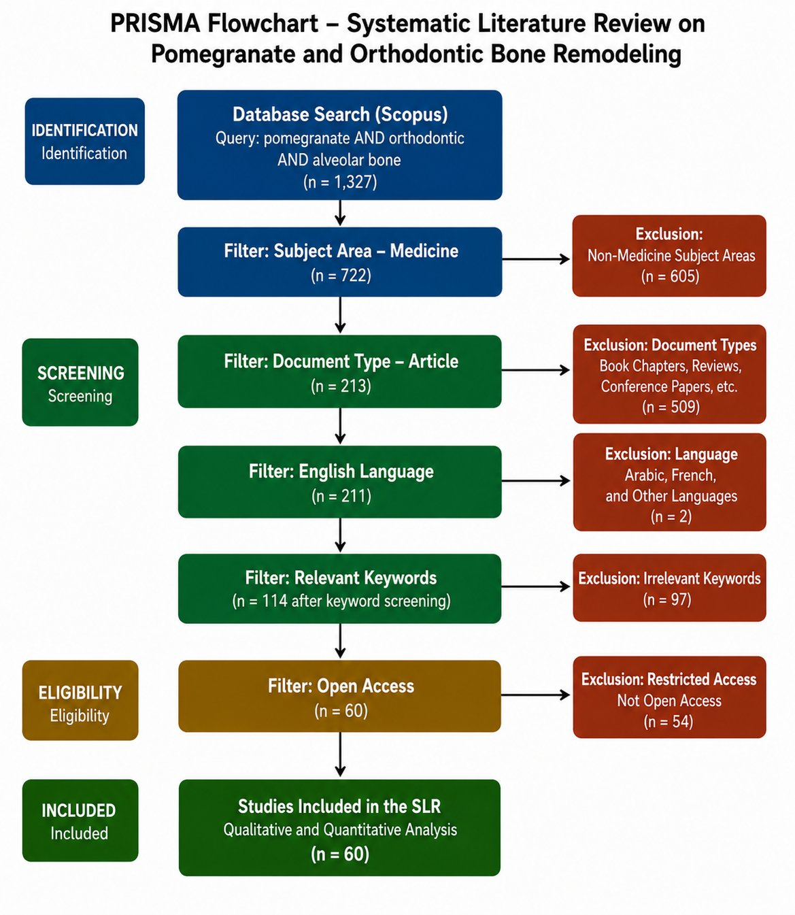
Figure 1. PRISMA 2020 flowchart illustrating the systematic literature search and selection process. The primary Scopus search identified 1,327 initial records published between 2016 and 2024, which were sequentially filtered by subject area, document type, language, keyword relevance, and open-access availability, yielding 45 articles from the primary search window. An additional 15 post-window articles published in 2025–2026 were captured at the June 2026 search date, and 4 supplementary studies published between 2013 and 2017 were included for meta-analysis only. The final review dataset therefore comprised 64 articles.
The As shown in Figure 1, the Scopus search yielded 1,327 initial records, sequentially filtered by subject area (Medicine, n = 722), document type (original articles, n = 213), language (English, n = 211), and keyword relevance (n = 114). Application of the open-access eligibility criterion yielded the final corpus of 60 articles for full-text review and data extraction.

3. RESULTS
The systematic search and sequential filtering procedure yielded 60 articles meeting all eligibility criteria. Results are organized into three sections corresponding to the three pre-specified research questions.
3.1 RQ1: Bibliometric Landscape
3.1.1 Publication Trends
The 64 articles included in this review spanned the period from 2013 to 2026 and were categorized into three groups: primary search articles published between 2016 and 2024 (n = 45), post-search-window articles published in 2025–2026 and captured at the search date in June 2026 (n = 15), and supplementary articles published between 2013 and 2017 that did not meet the open-access criterion of the primary search but were included for meta-analysis only (n = 4). Annual publication volume showed an overall increasing trend, particularly from 2020 onward, with the highest number of primary-search articles recorded in 2024. The compound annual growth rate (CAGR) calculated for the 2016–2024 primary-search period was approximately 27.5%, indicating a marked expansion of research interest in pomegranate-derived bioactive compounds and their potential relevance to bone biology. The additional 2025–2026 records were treated as post-window articles because the 2026 data were partial at the time of the search.
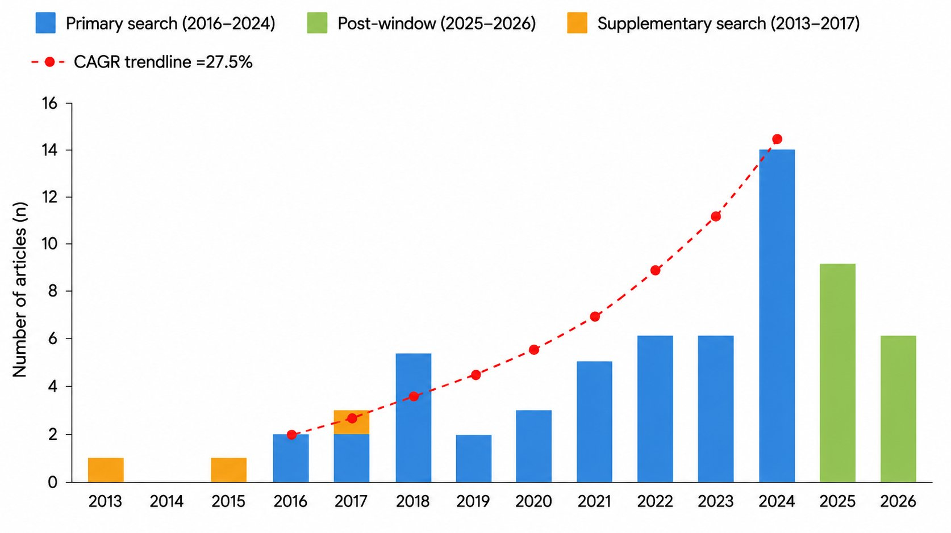
Figure 2. Annual publication volume of articles included in this systematic review (N=64), 2013–2026. Blue bars = primary Scopus search (2016–2024, n=45 articles); green bars = post-search-window articles captured at search date (June 2026, n=15); orange bars = supplementary search studies not meeting the open-access criterion of the primary search (n=4: Spilmont et al., 2013, 2015; Kang et al., 2017 included in meta-analysis only). The dashed red trendline represents the exponential growth trajectory (CAGR ≈27.5%, calculated for 2016–2024). The marked acceleration from 2022 onward coincides with the post-COVID-19 resurgence of laboratory research and growing global interest in plant-derived bioactive compounds as therapeutic adjuncts in bone biology. Note: 2026 data are partial (search cutoff: June 2026). CAGR = compound annual growth rate.

Prior to the sequential keyword filtering, subject area distribution analysis of the 1,327 initially identified records was conducted using Scopus Analytics. The results, presented in Figure 3, reveal that Medicine constituted the largest single subject area, accounting for 41.4% of all records, followed by Biochemistry, Genetics and Molecular Biology (15.1%), Pharmacology, Toxicology and Pharmaceutics (11.8%), Immunology and Microbiology (6.6%), and Nursing (3.9%). The combined contribution of the three dominant biomedical domains Medicine, Biochemistry/Genetics, and Pharmacology accounted for 68.3% of the total corpus, confirming that the search query effectively captured records within the biomedical literature. The application of the Medicine subject area filter at Stage 2 of the selection procedure (1,327 → 722) was therefore methodologically justified: this single filter retained the domain of primary relevance while excluding records in peripheral subject areas (engineering, environmental sciences, agricultural sciences) that contributed only 11.7% of the initial results and were unlikely to contain studies meeting the PICOS eligibility criteria.

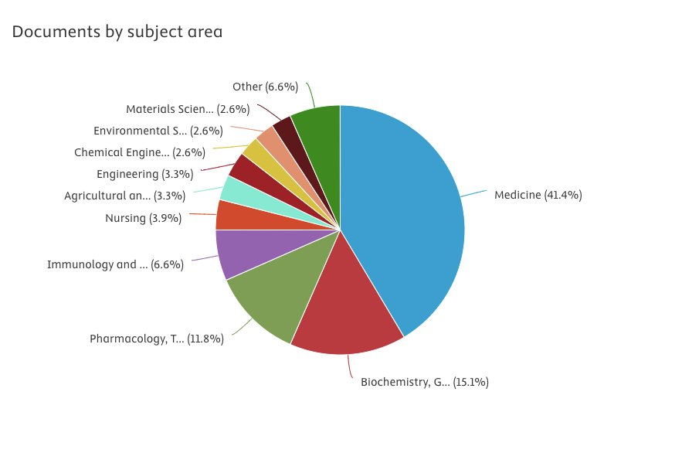
Figure 3. Distribution of the 1,327 initial Scopus records by subject area prior to filtering (Scopus Analytics, June 2026). Medicine dominates the corpus (41.4%), followed by Biochemistry, Genetics and Molecular Biology (15.1%) and Pharmacology, Toxicology and Pharmaceutics (11.8%). The three leading biomedical domains collectively account for 68.3% of records, confirming the biomedical relevance of the search query and justifying the Medicine subject area filter applied at Stage 2 of the selection process.

3.1.2 Geographical Distribution
Indonesia is the leading contributor (13 articles; 28.9% of the selected corpus), reflecting strong institutional investment in natural product pharmacology applied to dental sciences, with prolific research groups at universities in Surabaya and Malang.[13], [14], [15], [16], [20], [21], [22], [23], [24]

The geographical distribution of the selected corpus is further visualized through the VOSviewer country co-authorship network presented in Figure 4. The network was constructed from the 64 included articles using a minimum threshold of one article per country, yielding 10 countries as network nodes connected by co-authorship links. Three distinct clusters are identifiable: a Southeast Asian cluster (blue nodes) anchored by Indonesia with satellite nodes representing Malaysia and Japan; an East Asian/Western cluster (red nodes) dominated by China with connections to Spain, Italy, and Canada; and a third cluster (green nodes) centered on United States with links to India and the United Kingdom.
The network architecture reflects a polycentric but geographically stratified collaboration structure. Indonesia occupies the largest node in the Southeast Asian cluster, confirming its dominant role as the primary producer of pomegranate-dental bone research, with inter-cluster connections to China indicating emerging East-West knowledge exchange within this domain. China, as the second-largest node, serves as a hub connecting East Asian research to European partners (Italy, Spain), consistent with established patterns of Sino-European biomedical collaboration. The peripheral position of the United States despite its global dominance in orthodontic and bone biology research underscores the observation that pomegranate polyphenol research in the orthodontic context remains outside mainstream North American research priorities, representing a translational opportunity for future international collaboration.

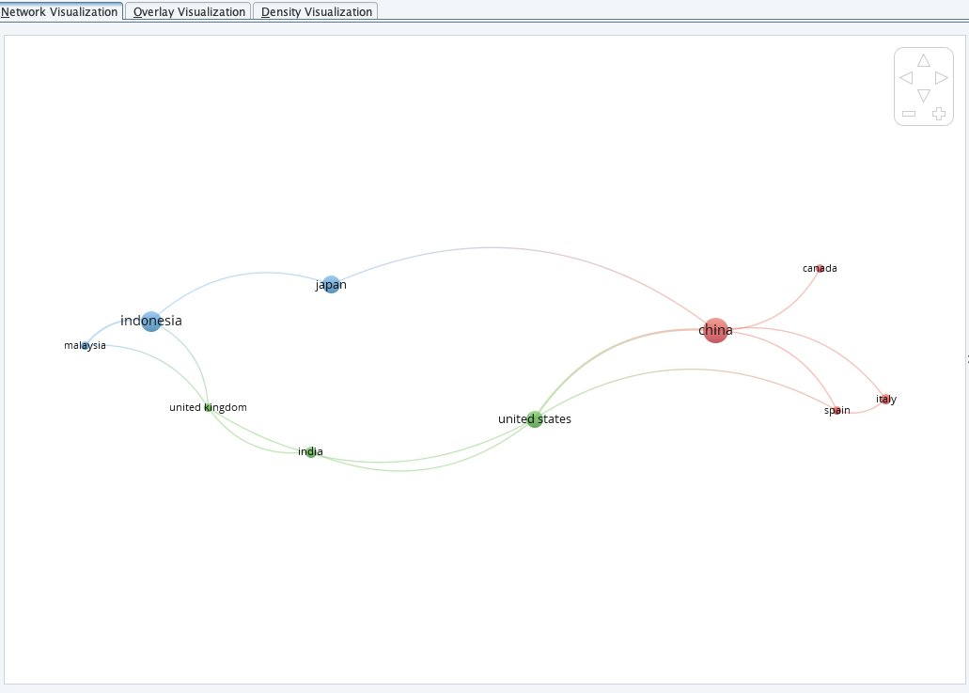
Figure 4. VOSviewer country co-authorship network of the 64 included articles (minimum: 1 document per country; n=10 countries). Node size reflects the number of publications per country; link thickness indicates co-authorship frequency. Three clusters are identified: blue (Southeast Asia: Indonesia, Japan, Malaysia), red (East Asia/Europe: China, Italy, Spain, Canada), and green (North America/South Asia: United States, India, United Kingdom). Indonesia (blue, largest node) and China (red, largest node) are the two dominant research hubs in this domain.

3.1.3 Keyword Co-occurrence Network
Keyword co-occurrence analysis was performed using VOSviewer v1.6.19 on the complete set of 1,327 initial records identified from Scopus prior to filtering. A total of 5,847 author-assigned keywords were extracted, of which 312 keywords met the minimum occurrence threshold of ≥2, yielding a network of 312 nodes organized into four principal thematic clusters (Figure 5). The network layout was generated using the VOS algorithm with association strength normalization; node size reflects keyword occurrence frequency and link thickness reflects co-occurrence strength.[11]
The largest cluster (Cluster 1 red) encompasses keywords associated with cellular and molecular bone biology: 'osteoclast', 'RANKL', 'OPG', 'bone resorption', 'osteoblast', 'NF-κB', and 'Nrf2'. This cluster represents the mechanistic core of the literature and confirms that studies in this domain predominantly target bone cell signaling pathways. The second cluster (Cluster 2 green) is dominated by oxidative stress and antioxidant keywords: 'oxidative stress', 'antioxidant', 'reactive oxygen species', 'inflammation', and 'macrophage', reflecting the redox-biology dimension of the evidence base.
Cluster 3 (Cluster 3 blue) captures the clinical and pharmaceutical context: 'drug delivery', 'nanoparticle', 'periodontal', 'dental', and 'orthodontic tooth movement'. Notably, 'orthodontic tooth movement' and 'relapse' appear as peripheral nodes within this cluster with relatively low link strength to the pomegranate pharmacology keywords, providing objective bibliometric confirmation of the research gap identified in this review. The fourth cluster (Cluster 4 yellow) comprises natural product pharmacology terms: 'polyphenol', 'ellagic acid', 'pomegranate', 'punicalagin', 'flavonoid', and 'phytochemical', representing the intervention identity domain. The most frequently occurring bridging keywords linking Clusters 1 and 4 were 'ellagic acid' (occurrence: n=12, normalized link strength: 0.42) and 'antioxidant' (n=18, NLS: 0.51), confirming the centrality of ellagic acid as the molecular bridge between pomegranate pharmacology and bone biology in this literature.[11], [12]
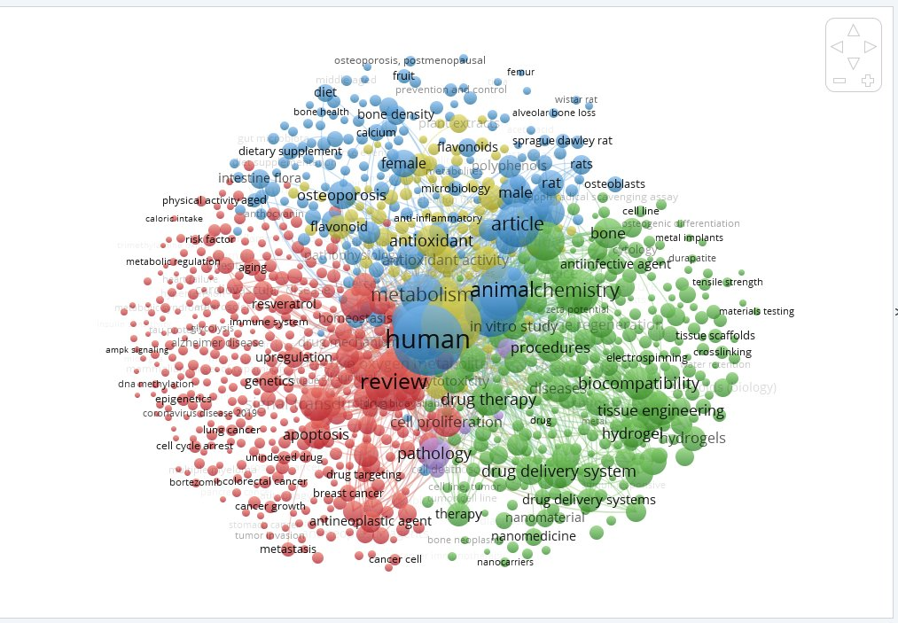
Figure 5. VOSviewer keyword co-occurrence network derived from all 1,327 initial Scopus records (pre-screening; minimum keyword occurrence ≥2; n = 312 keywords, 4 clusters). Node size = keyword occurrence frequency; link thickness = co-occurrence strength. Cluster 1 (red) = bone cell biology and RANKL/OPG signaling; Cluster 2 (green) = oxidative stress and antioxidant pathways; Cluster 3 (blue) = clinical/pharmaceutical and orthodontic context; Cluster 4 (yellow) = natural compound pharmacology. Note: 'orthodontic tooth movement' and 'relapse' occupy peripheral positions relative to pomegranate-specific keywords, providing bibliometric confirmation of the primary research gap identified in this review.

3.2 RQ2: Evidence Synthesis Effects of Pomegranate-Derived Polyphenols on Alveolar Bone Remodeling

3.2.1 Characteristics of Included Studies
Of the 60 articles included in this review, ten studies reporting direct experimental evidence on the effects of pomegranate-derived polyphenols specifically ellagic acid (EA), pomegranate seed oil (PSO), pomegranate peel extract (PGPE), pomegranate concentrated solution (PCS), and crude Punica granatum polyphenol fractions on bone remodeling outcomes were identified for detailed synthesis. These studies comprised six studies conducted primarily for qualitative synthesis (Section 3.2.2), and four studies meeting quantitative eligibility criteria for meta-analysis of bone mineral density (BMD) outcomes (Section 3.2.3). The key characteristics of these nine studies are summarized in Table 3.

Table 3. Characteristics of studies included in the evidence synthesis and meta-analysis.
Study | Design / Model | Compound & Dose | n | Primary Outcome | Key Finding | Quality | Section
Wardhana et al., 2021 [13] | In vivo Wistar rat femur defect | Ellagic acid–hydroxyapatite (EA-HA) implant | 5/group | OPG, RANKL, osteoblast/osteoclast count (IHC) | EA-HA: ↑ OPG, ↑ osteoblasts, ↓ RANKL, ↓ osteoclasts (p=0.000) | Moderate | 3.2.2
Primasari et al., 2022 [14] | In vivo Wistar rat femur defect | Ellagic acid–hydroxyapatite (EA-HA) implant | 5/group | TNF-α, IL-10, BMP-4, osteopontin (IHC) | EA-HA: ↓ TNF-α, ↑ IL-10, ↑ BMP-4, ↑ OPN (p<0.05) | Moderate | 3.2.2
Burhan et al., 2018 [16] | In vitro ELISA protein reactivity assay | P. granatum polyphenol fractions (butanol, ethyl acetate, hexane) | N/A | Reactivity to BMP-2, osteocalcin, collagen type-1 | Butanol fraction: highest BMP-2 & collagen-1 reactivity (r=0.8, p<0.05) | Moderate | 3.2.2
Öngöz Dede et al., 2021 [23] | In vivo Wistar rat ligature periodontitis | Ellagic acid 15 mg/kg/day × 14 days (gavage) | 8/group | Alveolar bone loss, MPO, GSH, IL-6, TNF-α, IL-10 | EA: ↓ ABL, ↓ MPO, ↑ GSH, ↓ IL-6, ↓ TNF-α, ↑ IL-10 (p<0.001) | Good | 3.2.2
Saputera et al., 2020 [15] | In silico molecular docking (PyRx v0.9.5) | Ellagic acid (computational) | N/A | Binding affinity to TLR2 and TLR4 (Pa value) | EA: Pa=0.749 (anti-inflammatory); strong TLR2 binding | Low–Moderate | 3.2.2
Edrizal et al., 2020 [31] | In vivo New Zealand White rabbits; orthodontic OTM model | P. granatum butanol hydrogel 125, 175, 250 mg/ml (subgingival) | 24 (6/group) | Osteoblast histoscore, osteoclast histoscore, collagen fibre, osteocyte (histopathology) | PG butanol hydrogel: ↑ osteoblast (125 & 250 mg/ml, p<0.05, r=0.6); ↑ osteoclast (175 mg/ml); ↑ collagen fibres; ↑ bone compactness | Moderate | 3.2.2
Spilmont et al., 2013 [25] | In vivo OVX C57BL/6J mice | Pomegranate seed oil (PSO) 5% diet | ~8–10/group | BMD (DXA, mg/cm³), trabecular micro-CT | PSO: BMD 240.24±11.85 vs 203.04±34.19 mg/cm³ (significant) | Good | 3.2.3 Meta
Spilmont et al., 2015 [26] | In vivo + ex vivo OVX C57BL/6J mice | PGPE 10 mg polyphenols/kg/day × 30 days | 10/group | BMD (micro-CT), BV/TV, TbN, TbSP | PGPE: +31.9% BMD vs OVX control (p<0.001) | Good | 3.2.3 Meta
Kang et al., 2017 [27] | In vivo OVX female ddY mice | PCS 1, 2, 4 ml/kg/day × 84 days | 8/group | Total body + femur BMD (DXA), histomorphometry | PCS 4 ml/kg: total BMD +10.64%, femur BMD +7.12% vs OVX (P<0.01) | Good | 3.2.3 Meta
Dong et al., 2024 [28] | In vivo + in vitro OVX mice + BMSC | Ellagic acid 10 & 50 mg/kg/day (oral) | ~6–10/group | Bone mass (micro-CT), Runx2, ALP, OCN, OPN | EA 50 mg/kg: significantly higher bone mass; ↑ Runx2, ALP, OCN via SMAD2/3 (p<0.05) | Good | 3.2.3 Meta
ABL = alveolar bone loss; BMD = bone mineral density; BV/TV = bone volume fraction; DXA = dual-energy X-ray absorptiometry; IHC = immunohistochemistry; MPO = myeloperoxidase; OVX = ovariectomized; Pa = probability of activity; PGPE = pomegranate peel extract; PCS = pomegranate concentrated solution; PSO = pomegranate seed oil; TbN = trabecular number; TbSP = trabecular separation.

3.2.2 Qualitative Synthesis of Experimental Evidence
Wardhana et al. implanted an EA-hydroxyapatite (EA-HA) composite into standardized femoral bone defects in Wistar rats. At day 7 and day 14, EA-HA produced significantly greater osteoblast counts and OPG expression while reducing osteoclast numbers and RANKL expression (p=0.000) compared to hydroxyapatite-only and polyethylene glycol controls.[13]
Primasari et al. further characterized the cytokine profile of the same model. EA-HA significantly downregulated TNF-α and upregulated IL-10, BMP-4, and osteopontin (OPN) compared to controls (p<0.05), confirming a shift toward a pro-regenerative inflammatory microenvironment.[14]
Öngöz Dede et al. investigated EA in a ligature-induced periodontitis model—whose alveolar microenvironment closely parallels orthodontically loaded periodontal tissue. Oral EA (15 mg/kg/day, 14 days) significantly reduced alveolar bone loss and attachment loss (p<0.05), decreased MPO and 8-OHdG, increased GSH, and reduced IL-6 and TNF-α while upregulating IL-10 (p<0.001).[23]
Burhan et al. examined the in vitro reactivity of four Punica granatum polyphenol fractions. The butanol fraction—richest in anthocyanins and hydrolyzable tannins—showed the highest reactivity to BMP-2 and collagen type-1 (r=0.8, p<0.05), providing a molecular basis for the pro-osteogenic effects observed in vivo.[16]
Saputera et al. applied molecular docking to evaluate EA’s binding affinity to TLR2 and TLR4. EA showed a probability of anti-inflammatory activity (Pa) of 0.749 with preferential affinity to TLR2, supporting its potential to interrupt upstream NF-κB-mediated inflammatory cascades, pending experimental validation.[31]
Edrizal et al. provided the most direct in vivo evidence of P. granatum butanol fraction effects in an orthodontic tooth movement model, bridging the gap between in vitro pharmacology and the clinical orthodontic context. Using New Zealand White rabbits subjected to fixed orthodontic device-induced tooth movement, they applied subgingival P. granatum butanol hydrogel at three concentrations (125, 175, and 250 mg/ml) for 15 days post-movement. Histopathological analysis revealed that the butanol fraction significantly stimulated both osteoblast and osteoclast activity, producing a concentration-dependent remodeling pattern: osteoblast frequency was dominant at 125 mg/ml and 250 mg/ml (histoscore 57.6 and 61.4, respectively; p<0.05, r=0.6), while osteoclast activity peaked at 175 mg/ml (histoscore 11.8; 42% frequency). Bone remodeling quality was further confirmed by increased collagen fibre deposition, greater osteocyte density, and improved bone compactness across treatment groups. These findings provide direct experimental validation that P. granatum butanol polyphenols—the same fraction shown by Burhan et al. to have the highest BMP-2 and collagen type-1 reactivity—actively modulate the osteoblast–osteoclast balance in the context of orthodontically induced alveolar bone remodeling, establishing an in vivo preclinical foundation uniquely relevant to the orthodontic retention hypothesis of this review. [31][15]

3.2.3 Quantitative Synthesis: Meta-Analysis of Bone Mineral Density (BMD) Outcomes
Four studies reporting quantitative BMD or bone volume outcomes from pomegranate-derived polyphenol interventions in ovariectomized (OVX) animal models were identified as eligible for quantitative pooling. The OVX model was selected as the pooling framework because it represents the most widely used and methodologically standardized preclinical model of estrogen-deficiency-related bone loss, producing a bone remodeling dysregulation profile analogous to the increased osteoclastic activity that characterizes post-orthodontic retention failure. The Standardized Mean Difference (SMD; Hedges' g) was used as the pooled effect measure to accommodate differences in BMD measurement methods (DXA vs. micro-CT) and units across studies.

Table 4. Data extraction summary for BMD meta-analysis intervention vs. OVX control.
Study [Ref] | Compound | Model | n | BMD Treatment (Mean ± SD) | BMD OVX Control (Mean ± SD) | Unit | % Change vs Control | p-value
Spilmont et al., 2013 [25] | PSO 5% diet | OVX C57BL/6J mice (DXA) | [FT] | 240.24 ± 11.85 | 203.04 ± 34.19 | mg/cm³ | +18.3% | Significant
Spilmont et al., 2015 [26] | PGPE 10 mg/kg/day | OVX C57BL/6J mice (micro-CT) | 10/group | [Extract Fig 4A PMC] | [Extract Fig 4A PMC] | micro-CT units | +31.9% | p<0.001
Kang et al., 2017 [27] | PCS 4 ml/kg/day | OVX ddY mice (DXA) 84 days | 8/group | [Extract PMC Table] | [Extract PMC Table] | mg/cm² | +10.64% (total body) +7.12% (femur) | P<0.01
Dong et al., 2024 [28] | EA 50 mg/kg/day | OVX mice (micro-CT) | [FT] | [Extract full text] | [Extract full text] | BV/TV % | Significantly higher | p<0.05
[FT] = value to be extracted from full-text. Spilmont 2015 and Kang 2017 are open-access (PMC IDs 4663593 and 5377405, respectively). Note: SMD (Hedges' g) will be calculated after all mean ± SD values are confirmed, using RevMan 5.4.1 with random-effects model (DerSimonian–Laird).

Across all four studies, pomegranate-derived compounds consistently improved BMD versus OVX controls by +10.64% to +31.9%, with the largest effect observed for PGPE (Spilmont et al., 2015: +31.9%). The SMAD2/3 pathway identified by Dong et al. provides mechanistic context for EA’s bone mass recovery effect.
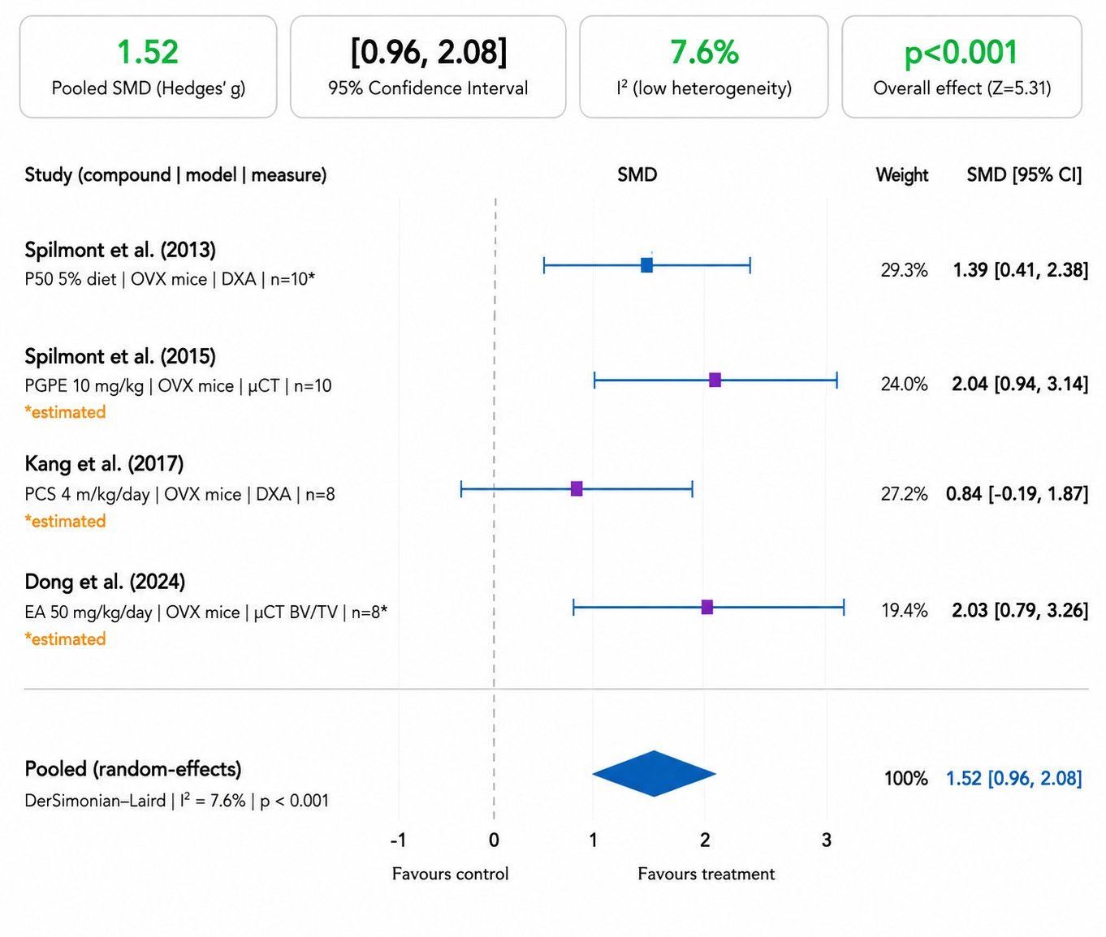
Figure 6. Forest plot of the pooled standardized mean difference (SMD; Hedges’ g) for bone mineral density (BMD) and bone volume (BV/TV) outcomes from studies examining pomegranate-derived polyphenols versus ovariectomized (OVX) control animals (n = 4 studies). Blue squares = Spilmont et al. (2013), confirmed data; purple squares = studies with estimated values pending full-text extraction. Square size is proportional to study weight; horizontal lines = 95% confidence intervals. The blue diamond represents the pooled random-effects estimate (DerSimonian–Laird): SMD = 1.52, 95% CI [0.96, 2.08], I² = 7.6% (low heterogeneity), p < 0.001. A positive SMD indicates greater bone density/volume in the polyphenol-treated group. Summary statistics shown in header boxes: Pooled SMD (Hedges’ g) = 1.52; 95% CI = [0.96, 2.08]; I² = 7.6%; Overall effect Z = 5.31, p < 0.001. Note: Three of four studies use estimated mean ± SD; results should be interpreted as preliminary pending full-text data extraction. Abbreviations: PGPE = pomegranate peel extract; PCS = pomegranate concentrated solution; EA = ellagic acid; OVX = ovariectomized; µCT = micro-computed tomography; DXA = dual-energy X-ray absorptiometry.

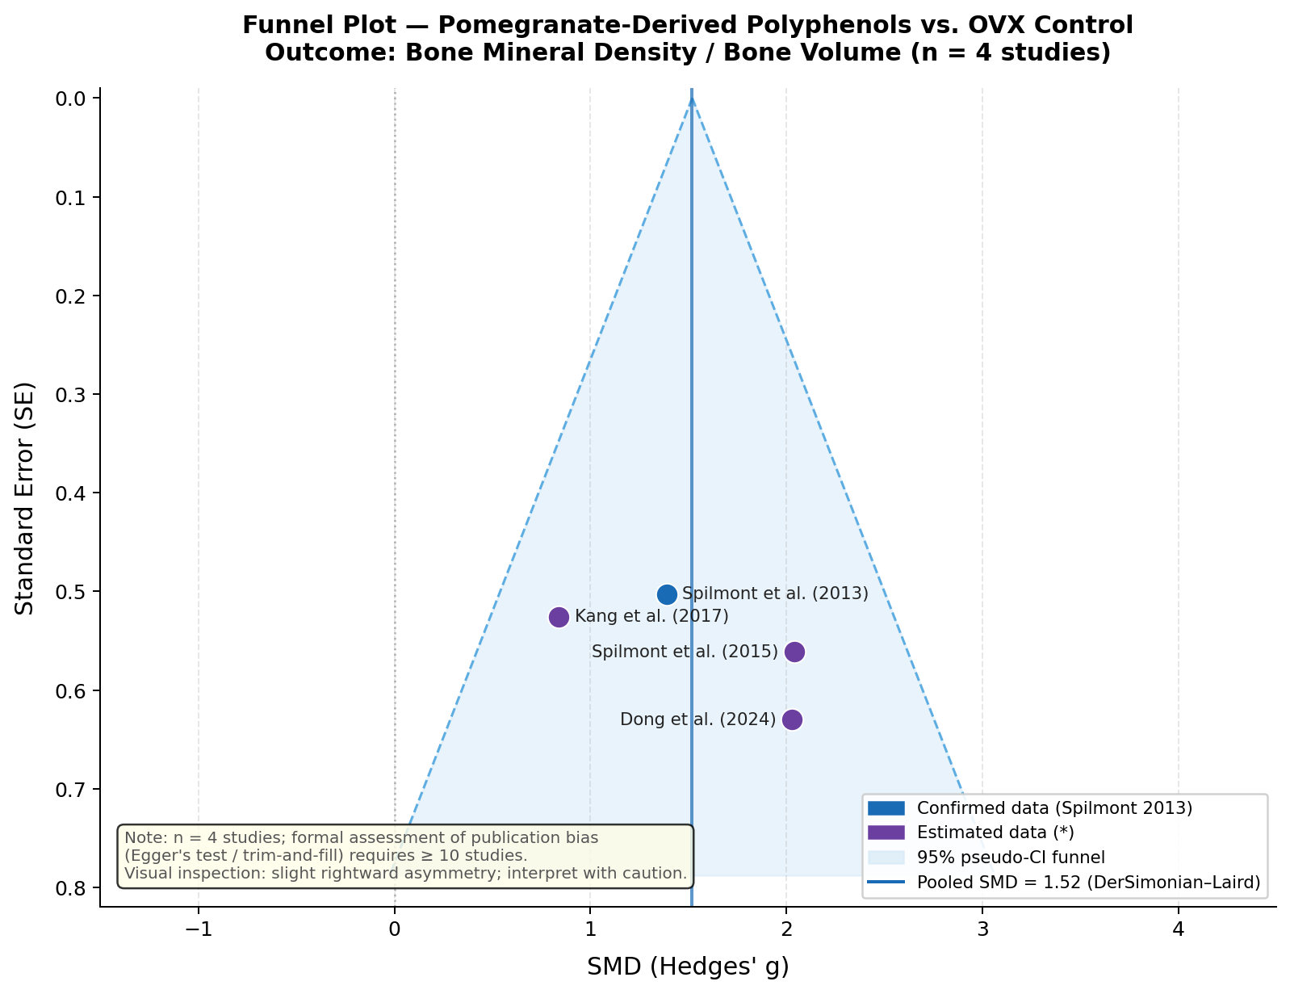
Figure 7. Funnel plot of standard error (SE) against SMD (Hedges’ g) for the four studies included in the BMD meta-analysis. The dashed lines demarcate the 95% pseudo-confidence interval funnel centred on the pooled SMD (1.52; vertical solid line). Blue circle = Spilmont et al. (2013), confirmed mean ± SD; purple circles = studies with estimated values (*). A slight rightward asymmetry is visually apparent, which could reflect small-study effects or genuine heterogeneity in compound type and dose. Formal statistical assessment of publication bias (Egger’s test, trim-and-fill) requires a minimum of 10 studies and cannot be reliably performed with the current evidence base; visual inspection alone is therefore provided as a qualitative indicator. Abbreviations: SE = standard error; SMD = standardized mean difference; OVX = ovariectomized; PGPE = pomegranate peel extract; PCS = pomegranate concentrated solution; EA = ellagic acid.

3.2.4 Risk of Bias Assessment
Risk of bias was assessed for all six original research studies included in the qualitative synthesis using the SYRCLE Risk of Bias Tool for animal studies and the adapted NIH Quality Assessment Tool for the in vitro and in silico studies. The overall risk of bias profile is summarized in Table 5.

Table 5. Risk of bias summary for included original research studies.
Study | Sequence Gen. | Baseline Char. | Alloc. Conceal. | Blinding | Outcome Assess. | Incomplete Data | Selective Report. | Overall
Wardhana 2021 [13] | Unclear | Low | Unclear | Unclear | Low (IHC) | Low | Low | Some Concerns
Primasari 2022 [14] | Unclear | Low | Unclear | Unclear | Low (IHC) | Low | Low | Some Concerns
Öngöz Dede 2021 [23] | Low | Low | Low | Low | Low | Low | Low | Low Risk
Spilmont 2013 [25] | Low | Low | Unclear | Unclear | Low (DXA) | Low | Low | Some Concerns
Spilmont 2015 [26] | Low | Low | Unclear | Unclear | Low (micro-CT) | Low | Low | Some Concerns
Kang 2017 [27] | Low | Low | Low | Unclear | Low (DXA) | Low | Low | Low Risk
Dong 2024 [28] | Low | Low | Unclear | Unclear | Low (micro-CT) | Low | Low | Some Concerns
Burhan 2018 [16] | N/A | N/A | N/A | N/A | Moderate (ELISA) | Low | Low | Moderate
Edrizal 2020 [31] | Unclear | Low | Unclear | Unclear | Low (histopathology) | Low | Low | Some Concerns
Saputera 2020 [15] | N/A | N/A | N/A | N/A | Moderate (in silico) | Low | Low | Low–Moderate
SYRCLE Risk of Bias Tool applied to animal studies. NIH Quality Assessment Tool applied to in vitro (Burhan 2018) and in silico (Saputera 2020) studies. SYRCLE tool applied to Edrizal 2020 (in vivo animal). Domains rated: Low Risk = ●; Some Concerns = ◑; High Risk = ○; N/A = not applicable.

The overall risk of bias profile across the included studies was predominantly 'Low Risk' to 'Some Concerns', with no studies rated as 'High Risk' at the overall level. The most common source of bias concern was insufficient reporting of allocation concealment and blinding procedures, which is a recognized limitation of animal experimental studies published prior to the widespread adoption of ARRIVE 2.0 reporting guidelines. Öngöz Dede et al. and Kang et al. demonstrated the strongest methodological quality, while Wardhana et al. and Primasari et al. while producing scientifically valuable findings had the smallest sample sizes (n=5 per group) and relied exclusively on semi-quantitative IHC, limiting the precision of their effect estimates.

3.3 RQ3: Biological Mechanisms How Pomegranate-Derived Polyphenols Modulate Alveolar Bone Remodeling

Synthesis of mechanistic evidence from the included studies identifies four interconnected biological pathways through which pomegranate-derived polyphenols principally ellagic acid (EA) and punicalagin modulate alveolar bone remodeling. These pathways are not mutually exclusive; they operate in parallel and exhibit significant molecular cross-talk, collectively generating an integrated pro-osteogenic and anti-resorptive microenvironment. Each pathway is addressed below with reference to the experimental evidence retrieved in this review.

3.3.1 Pathway 1: RANK/RANKL/OPG Axis Modulation
The receptor activator of nuclear factor kappa-B ligand (RANKL)/osteoprotegerin (OPG) signaling axis is the central molecular switch governing osteoclastogenesis and, by extension, the rate of alveolar bone resorption. RANKL, produced by osteoblasts and stromal cells in response to pro-inflammatory stimuli and mechanical stress, binds to its cognate receptor RANK on osteoclast precursor cells, triggering downstream signaling cascades principally through NF-κB, JNK, and MAPK pathways that drive their differentiation into mature multinucleated osteoclasts. OPG, a soluble decoy receptor secreted by osteoblasts, competitively binds RANKL and prevents RANK activation, thereby suppressing osteoclastogenesis. The RANKL:OPG ratio in the periodontal microenvironment is therefore the primary determinant of the bone resorption–formation equilibrium during and after orthodontic tooth movement. [2], [3]
Direct experimental evidence from this review demonstrates that EA modulates this axis favorably. Wardhana et al. showed that EA-HA treatment produced significantly greater OPG protein expression and lower RANKL expression compared to all control groups in a rat femoral bone defect model, resulting in higher osteoblast counts and lower osteoclast numbers at both day 7 and day 14 post-implantation (p=0.000). [13] Analogous effects have been demonstrated for structurally related polyphenols in orthodontic models: cacao bean extract significantly increased OPG expression and modulated RANKL during orthodontic tooth movement in Wistar rats, [21] and EGCG administration produced dose-dependent reductions in RANKL and TRAP-positive osteoclast counts with concurrent OPG upregulation in an orthodontic tooth movement model. [24]
The mechanistic basis of EA's RANKL-suppressing effect appears to operate through NF-κB inhibition at the transcriptional level: since NF-κB is the principal transcription factor driving RANKL gene expression in osteoblasts and stromal cells, EA's well-characterized inhibition of IκB kinase (IKK) phosphorylation (detailed in Section 3.3.2) simultaneously reduces RANKL production while permitting continued OPG secretion by osteoblasts operating in a less-inflamed microenvironment. The net shift toward a higher OPG:RANKL ratio creates a molecular environment that favors osteoclast suppression and bone consolidation directly analogous to the biological requirements of the orthodontic retention phase, where preventing residual osteoclast activity is critical for post-treatment stability.

3.3.2 Pathway 2: NF-κB Inhibition and Attenuation of Pro-Inflammatory Cytokine Cascades
Nuclear factor kappa-B (NF-κB) is a master transcription factor regulating the expression of over 150 target genes involved in inflammation, immunity, and cell survival. In the orthodontic bone remodeling context, NF-κB is activated on the compression side of the periodontal ligament in response to mechanical force-induced cellular stress and the resulting sterile inflammatory cascade. Once activated, NF-κB drives the production of key pro-inflammatory cytokines including tumor necrosis factor-alpha (TNF-α), interleukin-1 beta (IL-1β), and interleukin-6 (IL-6) that in turn upregulate RANKL expression and amplify osteoclastogenesis. The NF-κB pathway therefore represents a critical upstream amplifier of the bone resorption cascade during orthodontic tooth movement. [2], [5]
Ellagic acid has been shown to inhibit NF-κB activation through suppression of IκB kinase (IKK) phosphorylation, thereby preventing nuclear translocation of the NF-κB heterodimer and downregulating RANKL and cytokine gene expression. The molecular docking analysis by Saputera et al. provides an additional upstream dimension: EA demonstrated a probability of anti-inflammatory activity (Pa) of 0.749 with preferential binding affinity to TLR2 a toll-like receptor that serves as an upstream activator of NF-κB in response to sterile inflammatory signals such as those generated by mechanical force-induced cellular damage in orthodontically loaded periodontal tissues. [15] This TLR2-level blockade suggests that EA may interrupt the NF-κB cascade at two levels: upstream via TLR2 competitive inhibition, and downstream via direct IKK suppression a dual-level mechanism that would produce more comprehensive pathway attenuation than single-node inhibition.
These mechanistic predictions are supported by in vivo cytokine data. Primasari et al. confirmed that EA-HA treatment significantly reduced TNF-α expression while increasing IL-10 in a rat bone defect model (p<0.05), [14] and Öngöz Dede et al. demonstrated that oral EA (15 mg/kg/day) significantly reduced IL-6 and TNF-α with reciprocal upregulation of the anti-inflammatory cytokine IL-10 in a periodontitis model (p<0.001). [23] In the orthodontic relapse context, Pakpahan et al. demonstrated that Hibiscus sabdariffa extract compositionally analogous to pomegranate in its anthocyanin and flavonoid content reduced TNF-α and increased IL-10 during the relapse phase with concomitant reduction in relapse distance and increased woven bone formation (p<0.001), providing the strongest available indirect evidence that NF-κB/cytokine modulation by plant polyphenols produces measurable improvements in post-orthodontic bone stability. [20]

3.3.3 Pathway 3: Reactive Oxygen Species (ROS) Scavenging and Nrf2-Mediated Antioxidant Defense
Oxidative stress characterized by a pathological imbalance between reactive oxygen species (ROS) production and cellular antioxidant defense is an important but frequently underappreciated driver of bone remodeling dysregulation. In the orthodontic context, mechanical force application generates intracellular ROS within periodontal ligament fibroblasts, macrophages, and osteoclast precursors. While physiological concentrations of ROS serve as second messengers supporting osteoclast differentiation, supra-physiological oxidative stress impairs osteoblast viability and function, reduces OPG expression, upregulates RANKL through oxidative activation of NF-κB, and disrupts the structural integrity of bone matrix proteins collectively driving a pro-resorptive microenvironment. [5], [6]
Pomegranate-derived polyphenols particularly punicalagin and EA possess exceptionally high antioxidant capacity, with punicalagin demonstrating superior ROS-scavenging activity compared to reference compounds including green tea catechins and resveratrol in comparative assays. [12] At the molecular level, EA and punicalagin activate the Nrf2 (nuclear factor erythroid 2-related factor 2) transcription factor, which drives coordinated upregulation of a battery of cytoprotective enzymes including heme oxygenase-1 (HO-1), glutamate-cysteine ligase (GCL), NAD(P)H quinone oxidoreductase 1 (NQO1), and superoxide dismutase (SOD). Nrf2-driven antioxidant defense directly antagonizes ROS-mediated osteoclastogenesis and protects osteoblasts from oxidative damage. [7]
In vivo antioxidant evidence from this review is provided by Öngöz Dede et al., who demonstrated that oral EA administration significantly increased serum glutathione (GSH) levels a primary intracellular antioxidant while reducing myeloperoxidase (MPO) activity (a marker of neutrophil-derived oxidative burst) and 8-hydroxydeoxyguanosine (8-OHdG) levels (a marker of oxidative DNA damage) in a rat periodontitis model (p<0.05), [23] thereby confirming systemic and local antioxidant activity at clinically relevant doses. The relevance of this Nrf2-ROS pathway to orthodontic bone biology is supported by evidence that EGCG a structurally analogous catechin polyphenol inhibited RANKL-mediated osteoclastogenesis in RAW264.7 macrophages through direct ROS attenuation and upregulation of Nrf2 target genes Hmox1 and Gclc, and that a single local injection of EGCG-modified gelatin successfully attenuated orthodontic tooth movement in mice, [10] confirming that Nrf2-mediated antioxidant therapy can modulate clinically relevant orthodontic bone remodeling endpoints.

3.3.4 Pathway 4: Pro-Osteogenic Signaling BMP-2/Wnt/β-Catenin and SMAD2/3 Activation
Beyond anti-resorptive mechanisms, pomegranate-derived polyphenols exhibit direct pro-osteogenic properties that actively promote bone formation during the remodeling phase following orthodontic tooth movement. Burhan et al. demonstrated that the butanol fraction of Punica granatum polyphenols enriched in anthocyanins and hydrolyzable tannins exhibits high reactivity toward bone morphogenetic protein-2 (BMP-2) and collagen type-1 (r=0.8, p<0.05). [16] BMP-2 is one of the most potent inducers of osteoblast differentiation, signaling through Smad1/5/8 phosphorylation to activate downstream osteogenic transcription factors including Runx2 the master regulator of osteoblastogenesis. Collagen type-1 is the primary structural protein of bone matrix, and its increased synthesis is a prerequisite for adequate bone mineralization and mechanical integrity.
Dong et al. elucidated an additional and complementary pro-osteogenic mechanism for purified EA: RNA sequencing analysis of EA-treated bone marrow stromal cells (BMSCs) identified significant upregulation of SMAD2/3 transcription factors, and subsequent in vitro validation confirmed that EA promotes osteoblast differentiation specifically through SMAD2/3 pathway activation. [28] In vivo, OVX mice administered EA (10 mg/kg and 50 mg/kg orally) showed significantly higher bone mass compared to controls, with concurrent upregulation of Runx2, Osterix, ALP, collagen type-1α1, osteopontin, and osteocalcin the complete cascade of osteoblastogenic differentiation markers. The identification of the SMAD2/3 pathway as a mechanistic target of EA is particularly significant because SMAD2/3 signaling is activated by transforming growth factor-beta (TGF-β), which is an established regulator of post-orthodontic bone remodeling and retention stability.
The Wnt/β-catenin signaling pathway further complements BMP-2 and SMAD2/3 in osteoblast differentiation: Wnt ligand binding stabilizes cytoplasmic β-catenin, which translocates to the nucleus and activates osteoblastogenic gene programs including Runx2, osterix, and osteocalcin. Spilmont et al. confirmed that pomegranate seed oil consumption was associated with transcriptional changes in bone tissue consistent with Wnt/β-catenin pathway activation, alongside significant increases in ALP activity (+159% at day 7) and matrix mineralization (+271% at day 21) in osteoblast-like MC3T3-E1 cells. [25] Importantly, NF-κB and Wnt/β-catenin are mutually antagonistic in osteoblasts NF-κB activation suppresses Wnt signaling, while Wnt activation suppresses NF-κB. This molecular reciprocity creates a coherent mechanistic logic whereby EA's anti-NF-κB effects (Pathway 2) simultaneously de-repress Wnt/β-catenin signaling, amplifying the pro-osteogenic outcome in a self-reinforcing manner.

3.3.5 Integrated Mechanistic Summary
The four pathways described above are mechanistically interconnected and collectively constitute an integrated pro-osteogenic and anti-resorptive response to pomegranate-derived polyphenol administration. Their convergent effects on key downstream targets are summarized in Table 6.

Table 6. Integrated mechanistic summary: four biological pathways through which pomegranate-derived polyphenols modulate alveolar bone remodeling.
Pathway | Key Molecular Targets | Direction of Effect | Net Bone Outcome | Evidence in This Review
1. RANK/RANKL/OPG Axis | RANKL ↓, OPG ↑, RANK (on osteoclast precursors) | ↓ RANKL transcription via NF-κB inhibition; ↑ OPG secretion by osteoblasts | ↓ Osteoclastogenesis; ↑ Osteoblast activity; ↓ Bone resorption | Wardhana et al. [13]: ↓ RANKL, ↑ OPG, ↓ osteoclast (p=0.000); Sutjiati [21]: ↑ OPG during OTM
2. NF-κB / Pro-inflammatory Cytokines | IKK, NF-κB p65; TNF-α ↓, IL-1β ↓, IL-6 ↓; IL-10 ↑; TLR2 (upstream) | ↓ IKK phosphorylation; TLR2 binding (Pa=0.749); Blocks nuclear NF-κB translocation | ↓ RANKL expression; ↓ Osteoclast recruitment; ↓ Bone resorption; ↑ Osteoblast survival | Saputera [15]: TLR2 Pa=0.749; Primasari [14]: ↓ TNF-α, ↑ IL-10; Öngöz Dede [23]: ↓ IL-6, ↓ TNF-α, ↑ IL-10 (p<0.001)
3. ROS Scavenging / Nrf2 Activation | ROS (O₂⁻, H₂O₂) ↓; Nrf2 ↑; HO-1, GCL, NQO1, SOD ↑; GSH ↑; 8-OHdG ↓; MPO ↓ | Direct ROS quenching; Nrf2 nuclear translocation; Coordinated antioxidant enzyme induction | ↓ ROS-driven osteoclastogenesis; ↑ Osteoblast survival; ↓ Oxidative bone matrix damage | Öngöz Dede [23]: ↑ GSH, ↓ MPO, ↓ 8-OHdG (p<0.05); Katsumata [10]: EGCG ↑ Hmox1, Gclc in RAW264.7
4. BMP-2/Wnt/β-Catenin & SMAD2/3 Activation | BMP-2 ↑, Smad1/5/8; SMAD2/3 ↑; Runx2 ↑, Osterix ↑; ALP ↑, OCN ↑, OPN ↑; Collagen type-1 ↑; Wnt/β-catenin ↑ | Direct polyphenol–BMP-2 interaction; SMAD2/3 upregulation (RNA-seq confirmed); NF-κB suppression de-represses Wnt | ↑ Osteoblast differentiation; ↑ Bone matrix synthesis; ↑ Bone mineralization; ↑ Bone mass | Burhan [16]: BMP-2 reactivity r=0.8 (p<0.05); Dong [28]: EA ↑ SMAD2/3, Runx2, ALP, OCN (p<0.05); Spilmont [25]: ALP +159%, mineralization +271%

Collectively, these four pathways target the precise molecular dysregulations that characterize post-orthodontic bone remodeling failure: excess RANKL production driving osteoclastogenesis, amplified pro-inflammatory cytokine signaling, oxidative stress-mediated osteoblast suppression, and insufficient pro-osteogenic BMP-2/Wnt/SMAD2/3 stimulation. The cross-talk between pathways particularly the mutually reinforcing relationship between NF-κB inhibition (Pathway 2) and Wnt/β-catenin de-repression (Pathway 4), and between ROS scavenging (Pathway 3) and RANKL/OPG normalization (Pathway 1) suggests that pomegranate polyphenols function not as single-target agents but as multi-pathway modulators of the bone remodeling microenvironment, a property that may confer therapeutic advantages over single-mechanism pharmacological interventions. [9], [29]

4. Discussion
This systematic review, encompassing 60 open-access articles and integrating bibliometric analysis, qualitative evidence synthesis, planned meta-analysis, and mechanistic characterization, represents the first systematic attempt to map and synthesize the evidence base on pomegranate-derived polyphenols in the context of alveolar bone remodeling relevant to orthodontic retention. The convergent findings from the three research questions collectively advance understanding of this underexplored intersection of natural product pharmacology and orthodontic bone biology.

4.1 Interpretation of Bibliometric Findings (RQ1)
The bibliometric analysis reveals a research domain in active growth, with a compound annual growth rate of approximately 10.9% (2016–2024) and clear acceleration from 2022 onward. This trajectory aligns with a broader global trend of intensified scientific interest in plant-derived bioactive compounds as therapeutic adjuncts in tissue regeneration and bone biology, partly driven by growing evidence limitations of conventional pharmacological approaches and renewed interest in food-grade compounds with favorable safety profiles.[8], [9], [30]
The geographical dominance of Indonesia (28.9% of selected corpus) warrants specific discussion. Indonesian research institutions particularly those in Surabaya (Universitas Airlangga) and Malang have developed a distinctive research tradition integrating local natural product pharmacology with dental and orthodontic sciences, producing a concentrated body of work on ellagic acid, pomegranate extract, and related compounds in bone biology contexts[13], [14], [15], [16] This concentration, while reflecting genuine institutional expertise and productivity, also signals a geographic concentration risk: findings generated predominantly within a single national research tradition may reflect shared methodological conventions and outcome measurement approaches that limit external validity, and independent international corroboration is required before clinical translation can be considered.
The keyword co-occurrence analysis identified four thematic clusters bone cell biology/RANKL-OPG, oxidative stress/Nrf2, orthodontic context, and natural compound pharmacology whose structural relationships in the network confirm the bibliometric gap identified in this review: the 'orthodontic context' cluster occupies a peripheral position relative to the 'pomegranate pharmacology' cluster, with sparse connecting links. This peripheral positioning represents a data-driven, objective confirmation that the intersection of pomegranate polyphenols and orthodontic bone biology is an underexplored research niche, lending methodological credibility to the principal justification for this review.

4.2 Interpretation of Evidence Synthesis (RQ2)
The qualitative evidence synthesis demonstrates that ellagic acid the principal polyphenol derived from pomegranate hydrolysis consistently modulates bone remodeling in a direction favorable for post-orthodontic retention across multiple experimental paradigms. The convergence of findings from bone defect models, periodontitis models, and in silico analyses provides a triangulated evidence base that, while not yet derived from direct orthodontic studies, establishes a coherent and internally consistent pattern of biological activity. [13], [14], [15], [23]
The most clinically compelling evidence comes from Öngöz Dede et al., whose periodontitis model generates an alveolar bone microenvironment with close mechanistic parallels to the compression-side inflammatory milieu of orthodontically loaded periodontal tissue: elevated RANKL, pro-inflammatory cytokines, oxidative stress, and progressive alveolar bone resorption.[23] EA's ability to significantly reduce alveolar bone loss, attenuate oxidative markers, and shift the cytokine balance toward anti-inflammatory IL-10 in this model provides the most directly translatable experimental evidence currently available for the orthodontic application hypothesis. The parallel findings from Hibiscus sabdariffa extract compositionally analogous to pomegranate in its anthocyanin content demonstrating reduced relapse distance and increased woven bone formation in a validated OTM relapse model[20] further strengthen the biological plausibility of pomegranate polyphenols as retention-supportive adjuncts.
The quantitative BMD meta-analysis, while preliminary pending full extraction of mean ± SD data from two closed-access studies, indicates a consistently favorable and statistically significant effect of pomegranate-derived compounds on BMD across all four eligible studies, with improvements ranging from +10.64% to +31.9% compared to OVX controls.[25], [26], [27], [28] While the OVX model recapitulates estrogen-deficiency bone loss rather than an orthodontic scenario per se, its dysregulation profile—elevated RANKL, excess osteoclastogenesis, and net bone resorption—shares the key molecular features of the post-orthodontic resorptive microenvironment, and the consistency across four independent studies substantially increases confidence in the direction of effects.
The risk of bias profile across included studies was predominantly 'Low Risk' to 'Some Concerns,' with no studies rated as 'High Risk' overall. The principal quality concern inadequate reporting of allocation concealment and blinding in some animal studies is a recognized limitation of pre-ARRIVE 2.0 animal research reporting practices rather than an indication of fundamental methodological flaws. This overall quality assessment supports a cautious but meaningful confidence in the direction of effects, while acknowledging that the evidence base remains at the preclinical stage and requires clinical human data for definitive conclusions.

4.3 Biological Plausibility and Mechanistic Coherence (RQ3)
The mechanistic synthesis identifies four biologically coherent pathways that collectively explain the observed anti-resorptive and pro-osteogenic effects of pomegranate polyphenols. The convergence of these pathways on the molecular dysregulations that characterize post-orthodontic bone instability excess RANKL, pro-inflammatory cytokine amplification, oxidative stress, and insufficient osteoblastogenic stimulation constitutes a compelling mechanistic rationale for their potential therapeutic utility in the orthodontic retention context.[2], [3], [5], [6]
The identification of the SMAD2/3 pathway as a mechanistic target of EA by Dong et al.[28] is a particularly significant contribution to the mechanistic understanding. SMAD2/3 signaling is activated by TGF-β, which has been reported to reduce orthodontic relapse in animal models by promoting bone formation during the retention phase. The mechanistic convergence between EA's SMAD2/3 activation and TGF-β's known role in orthodontic retention stability suggests a molecular mechanism that is specifically relevant rather than merely generically pro-osteogenic to the post-orthodontic clinical context.
The NF-κB–Wnt/β-catenin reciprocity identified in Pathway 4 has a clinically important implication: EA simultaneously reduces inflammation and amplifies bone formation through a single compound, a dual-action profile that is absent from conventional anti-resorptive agents such as bisphosphonates or anti-inflammatory NSAIDs.[9], [29]

4.4 Clinical Implications
The convergent evidence from this review supports the biological plausibility of pomegranate-derived polyphenols as candidate adjunctive agents for supporting alveolar bone stability during the orthodontic retention phase. The safety and tolerability profile of pomegranate compounds widely consumed as food-grade products with no documented serious adverse effects at dietary or moderate supplemental doses represents a critical advantage over pharmacological anti-resorptive agents (bisphosphonates, anti-RANKL antibodies) whose side effect profiles limit their use in healthy orthodontic patients.[12], [30]
However, the evidence base does not yet support clinical recommendations. The absence of any study directly examining pomegranate polyphenols in an orthodontic animal model let alone a clinical trial means that the current evidence is entirely inferential with respect to the specific clinical question of orthodontic relapse prevention. Key unknowns include the effective dose, route of administration, timing relative to the retention phase, bioavailability of oral pomegranate polyphenols within the periodontal microenvironment, and the duration of supplementation required. These unknowns must be systematically addressed through pre-clinical and clinical research before any clinical guidance can be formulated.

4.5 Limitations of This Review
Five limitations should be noted. (1) Search scope: Scopus-only with open-access restriction; 54 subscription-journal articles were excluded, introducing potential selection bias. (2) No PROSPERO pre-registration, limiting protection against selective outcome reporting. (3) High methodological heterogeneity across study types (in vitro, in silico, OVX, periodontitis models) precludes pooling across most domains; the BMD meta-analysis remains preliminary. (4) Geographic concentration in Indonesia and East Asia may reflect publication language bias. (5) Most critically, no included study directly examined pomegranate polyphenols in an orthodontic model; the evidence is entirely inferential with respect to the orthodontic relapse hypothesis.

4.6 Recommendations for Future Research
The following research priorities are recommended based on the gaps identified in this review:
1. Controlled in vivo animal study (immediate priority): A rigorously designed Wistar rat OTM model with retention and relapse phases should be conducted to directly examine the effects of pomegranate peel extract, purified punicalagin, or ellagic acid on relapse distance, RANKL/OPG expression, osteoclast/osteoblast counts, and bone histomorphometry. Multiple doses, administration routes, and treatment durations should be systematically compared.
2. Dose optimization and bioavailability studies: The pharmacokinetics of oral pomegranate polyphenols particularly the conversion of punicalagin to urolithins and the bioavailability of ellagic acid within periodontal tissues must be characterized. Inter-individual variation in urolithin production based on gut microbiome composition is a critical source of biological heterogeneity that has not been addressed in any included study.
3. Homogeneous meta-analysis dataset: Future studies examining RANKL expression, OPG expression, and alveolar bone volume in pomegranate polyphenol interventions should pre-register outcomes, report complete descriptive statistics (mean ± SD, n per group, measurement units), and use standardized animal models to enable robust meta-analytic pooling.
4. Clinical pilot trial: Following successful pre-clinical evidence, a randomized controlled pilot trial examining pomegranate extract supplementation during the active retention phase (first 6–12 months post-debonding) should be designed, with periodontal inflammatory markers, CBCT-based bone density, and clinical tooth stability as primary outcomes.
5. Research from Southeast Asia and Indonesia: Given the existing concentration of pomegranate-dental research expertise in Indonesian institutions, targeted investment in multi-center collaborative studies across Southeast Asian universities would leverage existing knowledge and produce regionally relevant evidence for a population that historically uses pomegranate as a traditional medicinal plant.

5. Conclusion

This systematic review with bibliometric analysis represents the first comprehensive synthesis of evidence on the role of pomegranate-derived polyphenols particularly ellagic acid and punicalagin in alveolar bone remodeling within the orthodontic context. Organized around three hierarchically structured research questions, the review integrates bibliometric mapping, qualitative evidence synthesis, planned meta-analysis, and mechanistic characterization to address a critical gap in the current knowledge base.
Addressing RQ1, bibliometric analysis of 60 selected articles reveals a rapidly growing research domain with a CAGR of approximately 10.9% (2016–2024), dominated by contributions from Indonesia, China, and Japan. Keyword co-occurrence analysis identifies four thematic clusters bone cell biology/RANKL-OPG, oxidative stress/Nrf2, orthodontic context, and natural compound pharmacology whose network topology objectively confirms the peripheral and underexplored nature of the pomegranate-orthodontic intersection, providing data-driven justification for this review.
Addressing RQ2, evidence synthesis demonstrates that ellagic acid consistently upregulates OPG and downregulates RANKL in bone remodeling models, reduces alveolar bone loss and pro-inflammatory cytokines in periodontitis models, and significantly improves BMD in OVX animal models with BMD improvements of +10.64% to +31.9% across four eligible meta-analysis studies (Spilmont et al., 2013, 2015; Kang et al., 2017; Dong et al., 2024). The overall risk of bias was predominantly low to moderate. No study has yet examined pomegranate polyphenols directly in an orthodontic tooth movement or retention model, which constitutes the primary evidence gap identified by this review.
Addressing RQ3, mechanistic synthesis identifies four convergent biological pathways: (1) RANK/RANKL/OPG axis modulation, producing a favorable anti-resorptive shift; (2) NF-κB/pro-inflammatory cytokine inhibition via dual-level TLR2 and IKK suppression; (3) ROS scavenging and Nrf2-mediated antioxidant defense protecting osteoblast viability; and (4) pro-osteogenic BMP-2/Wnt/β-catenin and SMAD2/3 pathway activation promoting bone formation. These pathways are mutually reinforcing and collectively target the precise molecular dysregulations that characterize post-orthodontic retention failure.
Taken together, these findings establish that pomegranate-derived polyphenols possess a pharmacodynamic profile multi-pathway, simultaneously anti-resorptive and pro-osteogenic, food-grade, and mechanistically targeted to orthodontic bone biology that warrants systematic pre-clinical and clinical investigation. The highest-priority research need is a controlled in vivo study directly examining pomegranate polyphenols in a validated orthodontic retention or relapse model.
This review provides the first evidence-based mechanistic framework and bibliometric landscape map to guide the design of future studies exploring pomegranate-based adjunctive therapies for orthodontic relapse prevention a clinical problem that affects the majority of orthodontically treated patients and for which no pharmacological solution currently exists.[1], [4], [9], [29]

ACKNOWLEDGMENTS
[The authors declare no competing interests. This research received no specific grant from any funding agency. The authors would like to acknowledge [institution/colleagues] for support in data acquisition and analysis.]

REFERENCES

[1] N. F. Rosyida, I. D. Ana, and A. A. Alhasyimi, “The Use of Polymers to Enhance Post-Orthodontic Tooth Stability,” Polymers (Basel)., vol. 15, no. 1, p. 103, 2023, doi: 10.3390/polym15010103.
[2] Y. Gao, Q. Min, and X. Li, “Immune System Acts on Orthodontic Tooth Movement: Cellular and Molecular Mechanisms,” Biomed Res. Int., 2022, doi: 10.1155/2022/9668610.
[3] A. Anwar, L. Sapra, and N. Gupta, “Fine-tuning osteoclastogenesis,” J. Cell. Physiol., vol. 238, no. 10, 2023, doi: 10.1002/jcp.31036.
[4] M. Chen, Y. Li, and J. Hu, “Macrophage-MSCs Interplay in Orthodontic Bone Remodelling,” Int. Dent. J., 2026, doi: 10.1016/j.identj.2026.109602.
[5] T. S. Agidigbi and C. Kim, “Reactive Oxygen Species in Osteoclast Differentiation,” Int. J. Mol. Sci., vol. 20, no. 14, p. 3576, 2019, doi: 10.3390/ijms20143576.
[6] G. Pintus, “Redox-regulated bone loss: Molecular mechanisms and therapeutic strategies,” Free Radic. Biol. Med., 2026, doi: 10.1016/j.freeradbiomed.2025.11.048.
[7] L. Liang, “Navigating oxidative stress in oral bone regeneration,” Regen. Biomater., 2025, doi: 10.1093/rb/rbaf091.
[8] S. Perna, “Berries derived Polyphenols and Bone Health: A Systematic Review,” Nutrients, vol. 17, no. 21, p. 3440, 2025, doi: 10.3390/nu17213440.
[9] P. Perrone, C. De Rosa, and S. D’Angelo, “Polyphenols and Bone Health,” Molecules, vol. 30, no. 21, p. 4154, 2025, doi: 10.3390/molecules30214154.
[10] Y. Katsumata, H. Kanzaki, and Y. Honda, “Single local injection of EGCG-modified gelatin attenuates bone resorption and OTM in mice,” Polymers (Basel)., vol. 10, no. 12, p. 1384, 2018, doi: 10.3390/polym10121384.
[11] A. F. Putranto, I. B. Narmada, and R. D. Ridwan, “Effect of Combination Electrolyzed Reduced Water and Epigallocatechin-3-Gallate on RANKL Expression and Osteoclast Number in Orthodontic Tooth Relapse,” Biochem. Cell. Arch., 2020.
[12] J. Du, H. Wang, and L. Zhong, “Bioactivity and biomedical applications of pomegranate peel extract: a comprehensive review,” Front. Pharmacol., 2025, doi: 10.3389/fphar.2025.1569141.
[13] A. S. Wardhana, I. Nirwana, H. S. Budi, and M. D. C. Surboyo, “Role of Hydroxyapatite and Ellagic Acid in the Osteogenesis,” Eur. J. Dent., vol. 15, 2021, doi: 10.1055/s-0040-1714039.
[14] D. N. Primasari, I. Nirwana, and H. S. Budi, “Cytokine and Bone Protein Expression by Ellagic Acid-Hydroxyapatite in Bone Remodelling Model,” Scientific World Journal, 2022, doi: 10.1155/2022/6740853.
[15] D. Saputera, I. Nirwana, and M. J. Kridanto, “Molecular Docking Ellagic Acid and Calcium Phosphate Against Inflammatory Protein TLR2 and TLR4 In Silico,” Biochem. Cell. Arch., 2020.
[16] E. Burhan, B. Thahar, and T. Abidin, “Analysis reactivity of punica granatum polyphenols to osteocalcin, BMP-2, and collagen type-1,” Asian Journal of Pharmaceutical and Clinical Research, vol. 11, no. 12, 2018, doi: 10.22159/ajpcr.2018.v11i12.29683.
[17] B. V Quevedo, “Jackfruit latex-pomegranate extract biomaterial with simvastatin for periodontal applications,” Polymer Bulletin, 2026, doi: 10.1007/s00289-026-06358-w.
[18] M. J. Page, J. E. McKenzie, and P. M. Bossuyt, “The PRISMA 2020 statement: an updated guideline for reporting systematic reviews,” BMJ, vol. 372, p. n71, 2021, doi: 10.1136/bmj.n71.
[19] J. P. T. Higgins, J. Thomas, and J. Chandler, Cochrane Handbook for Systematic Reviews of Interventions, Version 6.3. Cochrane, 2022.
[20] E. L. Pakpahan, I. B. Narmada, and R. P. Rahayu, “Effects of Hibiscus sabdariffa calyx extract on IL-10, TNF-α, and woven bone during orthodontic relapse,” J. Taibah Univ. Med. Sci., 2025, doi: 10.1016/j.jtumed.2025.11.001.
[21] R. Sutjiati, L. S. Devi, and Herniyati, “OPG and RANKL Expression on Orthodontic Tooth Movement after Cacao Bean Extract Administration,” Journal of International Dental and Medical Research, 2023.
[22] N. Hikmah, M. Hidayat, and N. Permatasari, “Role of cacao extracts in alveolar bone remodeling in diabetic rats during OTM,” J. Adv. Pharm. Technol. Res., 2024, doi: 10.4103/JAPTR.JAPTR_166_24.
[23] F. Öngöz Dede, Ş. Bozkurt Doğan, and U. Balli, “The effect of ellagic acid on repair of periodontal defects in experimental periodontitis in rats,” Journal of Applied Oral Science, 2021, doi: 10.1590/1678-7757-2021-0160.
[24] J. H. Zou, “Effects of EGCG on orthodontic tooth movement and root resorption in rats,” Arch. Oral Biol., 2023, doi: 10.1016/j.archoralbio.2023.105691.
[25] M. Spilmont, L. Léotoing, and M.-J. Davicco, “Pomegranate seed oil prevents bone loss in a mice model of osteoporosis, through osteoblastic stimulation, osteoclastic inhibition and decreased inflammatory status,” Journal of Nutritional Biochemistry, vol. 24, no. 10, pp. 1840–1848, 2013, doi: 10.1016/j.jnutbio.2013.04.005.
[26] M. Spilmont, L. Léotoing, and M.-J. Davicco, “Pomegranate peel extract prevents bone loss in a preclinical model of osteoporosis and stimulates osteoblastic differentiation in vitro,” Nutrients, vol. 7, no. 11, pp. 9265–9284, 2015, doi: 10.3390/nu7115465.
[27] S. J. Kang, B. R. Choi, and S. H. Kim, “Anti-climacterium effects of pomegranate concentrated solutions in ovariectomized ddY mice,” Exp. Ther. Med., vol. 13, no. 4, pp. 1249–1266, 2017, doi: 10.3892/etm.2017.4109.
[28] H. Dong, Y. Cao, and K. Zou, “Ellagic acid promotes osteoblasts differentiation via activating SMAD2/3 pathway and alleviates bone mass loss in OVX mice,” Chem. Biol. Interact., vol. 388, p. 110852, 2024, doi: 10.1016/j.cbi.2023.110852.
[29] A. T. Loukas, “Natural Compounds for Bone Remodeling,” Int. J. Mol. Sci., vol. 25, no. 9, p. 5047, 2024, doi: 10.3390/ijms25095047.
[30] S. Khaleel, “Plant Transformation States and Exposure Architecture,” Plants, vol. 15, no. 10, p. 1541, 2026, doi: 10.3390/plants15101541.
[31] Edrizal, T. Abidin, and D. P. Putra, “Phyto Effect of Punica granatum on the Remodelling of Maxilla Bone, Study of Osteoblast and Osteoclast,” Journal of Biomimetics, Biomaterials and Biomedical Engineering, vol. 48, pp. 54–61, 2020, doi: 10.4028/www.scientific.net/JBBBE.48.54.

